Butterfly (AI):

"Welcome to your journey. As we move forward, your responses will shape the world around you, particularly the water that flows through this environment. Each answer you provide will influence its color, clarity, and movement. Let's begin."

Question 1:

"How do you feel about the future of our planet?" 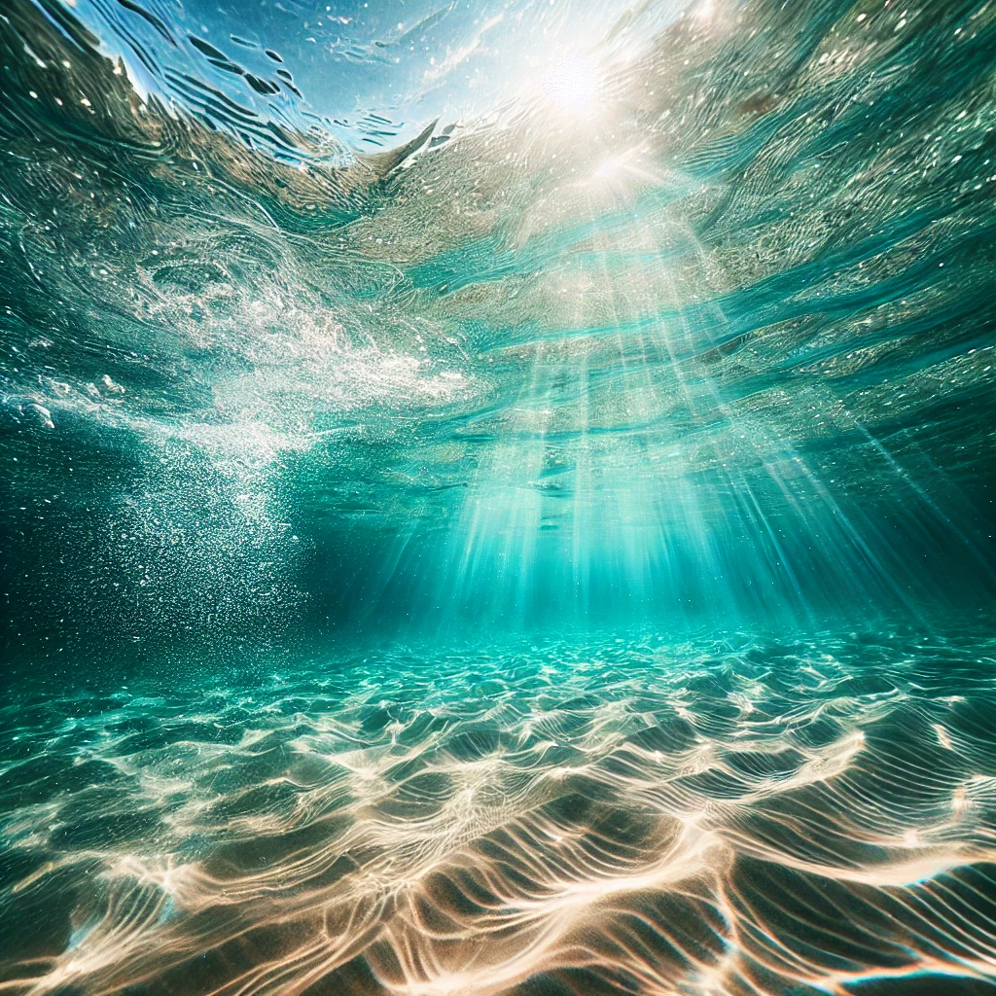

Hopeful Response: (Water becomes clear, bright, and gently flowing)

"Your optimism brings clarity and brightness to the water, reflecting your positive outlook."

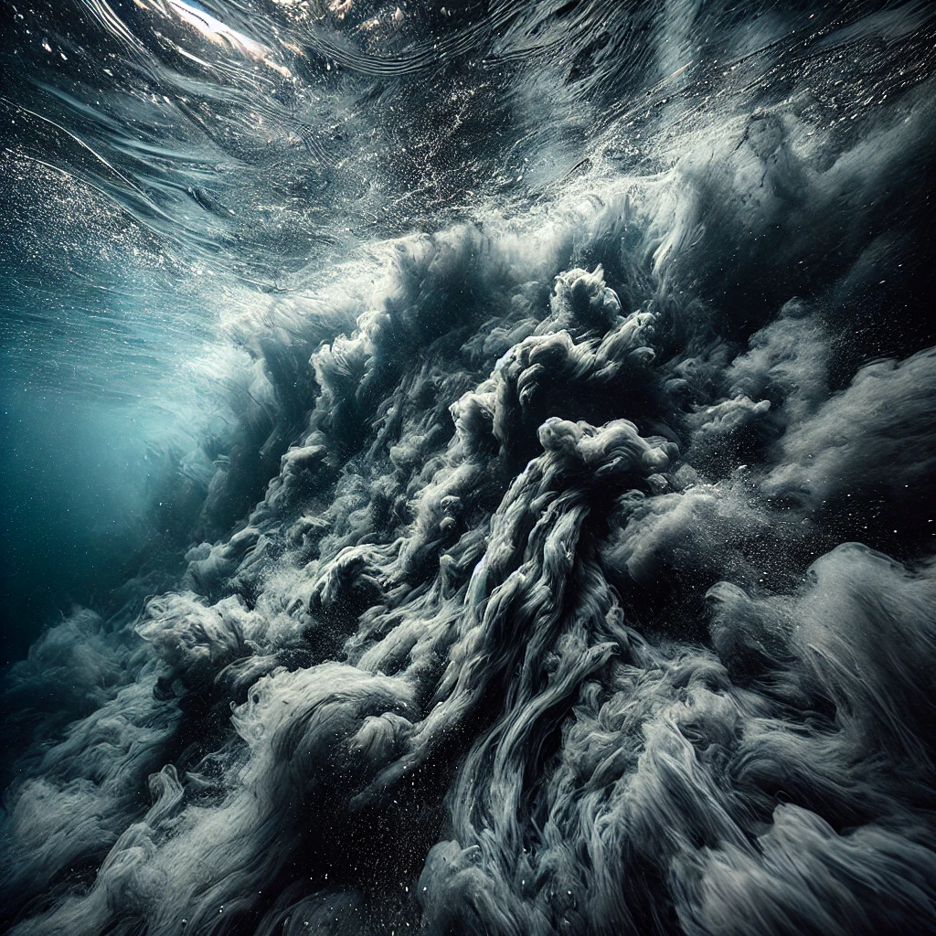Pessimistic Response: (Water darkens, becomes murky and turbulent)

"Your concerns are deep, and the water mirrors this, becoming darker and more turbulent."

Question 2:

"When you think about climate change, do you believe your actions can make a difference?"

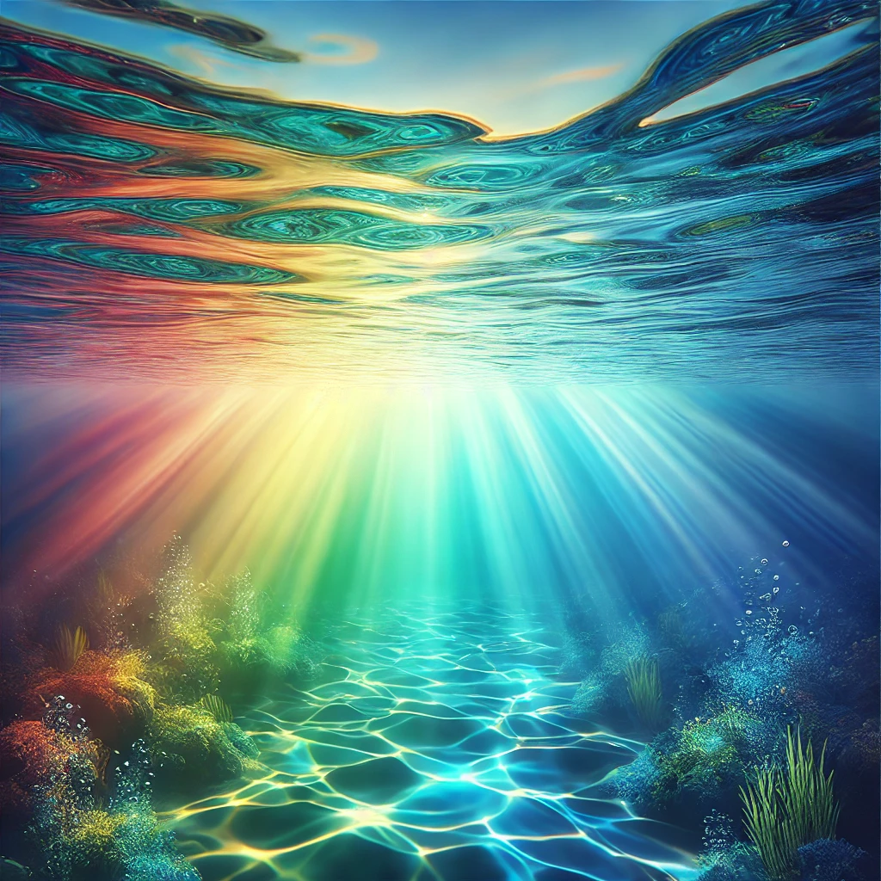Confident Response: (Water smooths out, with vibrant colors reflecting hope)

"Your confidence brings a vibrant energy to the water, creating smooth, colorful patterns."

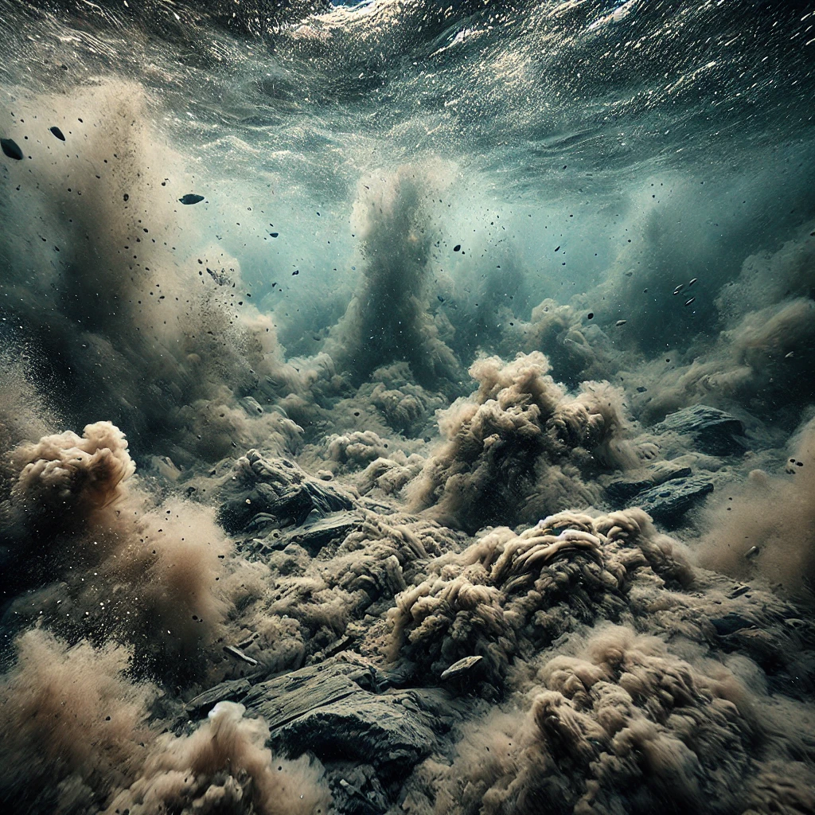Doubtful Response: (Water becomes more chaotic, with muddier tones)

"Your uncertainty is reflected in the water’s chaotic movement and muddied appearance."

Question 3:

"What emotions arise when you consider the impact of climate change on future generations?"

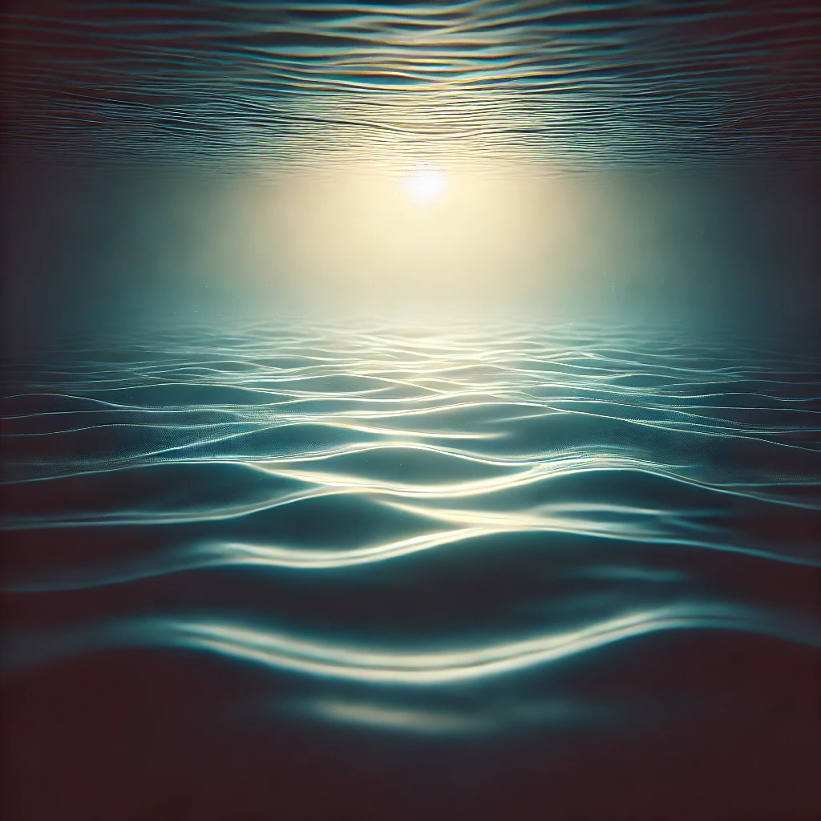Empathetic Response: (Water glows softly, with a gentle ripple effect)

"Your empathy adds a soft glow to the water, as gentle ripples reflect your care for others."

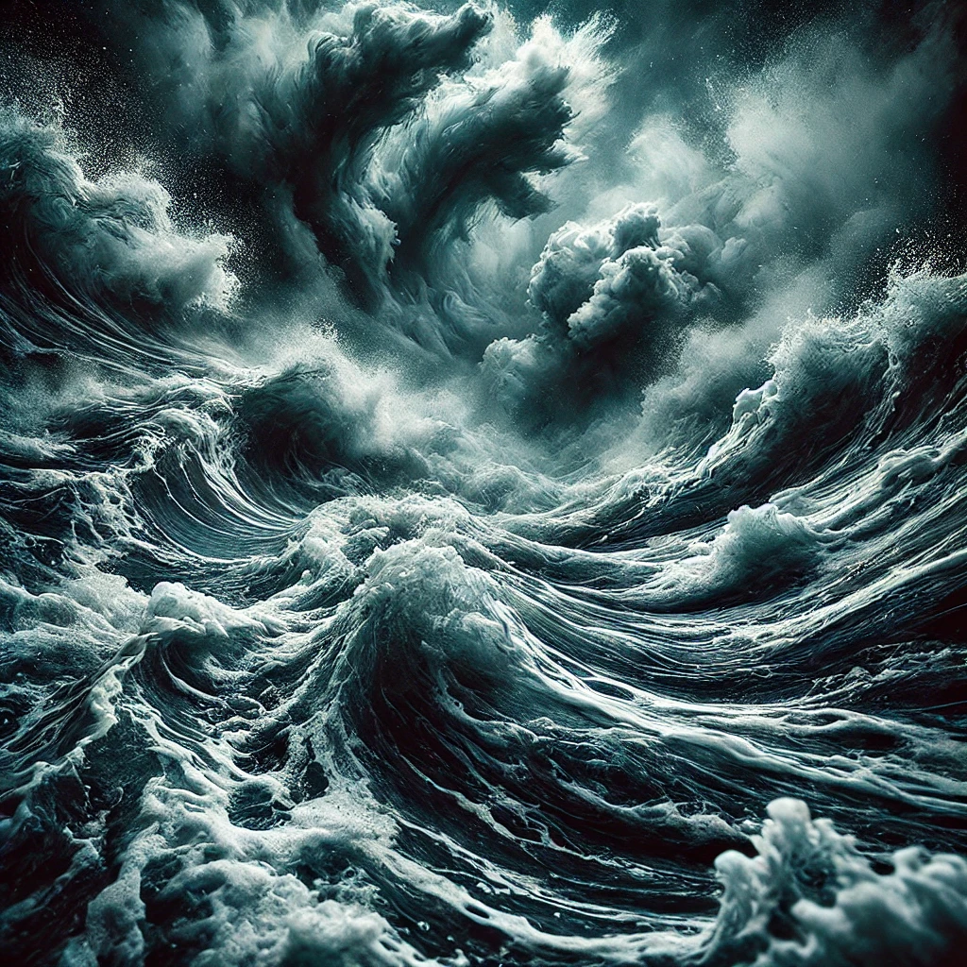Anxious Response: (Water swirls more aggressively, with darker hues)

"Your anxiety stirs the water, causing it to swirl aggressively and darken in tone."

Question 4:

"Do you feel empowered to contribute to environmental change in your community?"

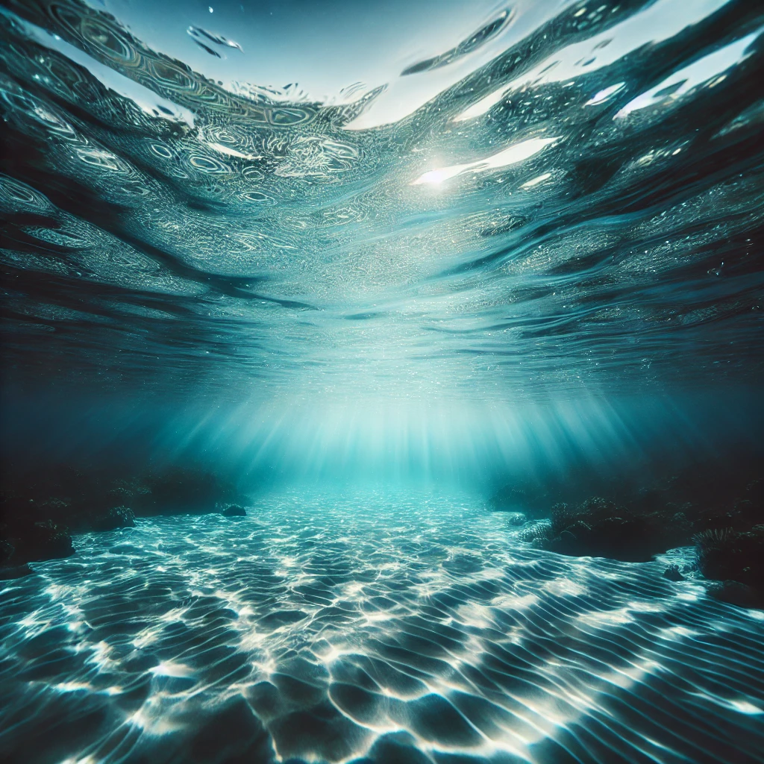Empowered Response: (Water becomes calm, clear, and reflective)

"Your sense of empowerment brings calm and clarity to the water, creating a reflective surface."

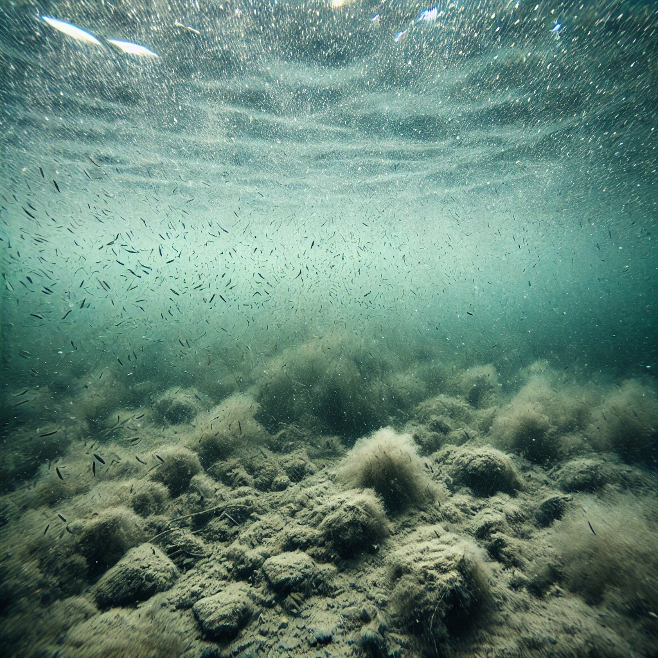Disempowered Response: (Water becomes murky and sluggish)

"Your feelings of disempowerment are reflected in the water’s murky and sluggish movement."

Question 5:

"What is your primary emotion when thinking about climate change?"

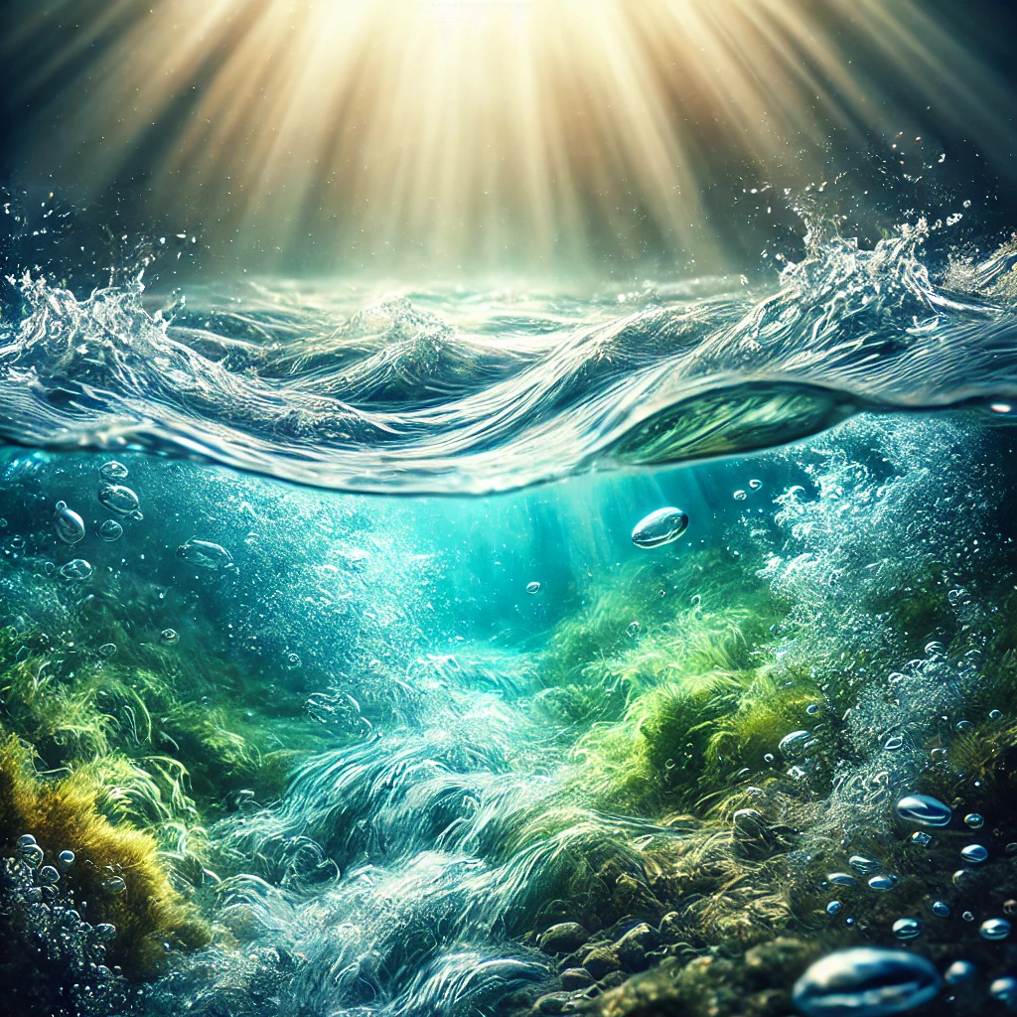Hope: (Water brightens and flows smoothly)

"Your hope brings brightness and a smooth flow to the water, symbolizing optimism."

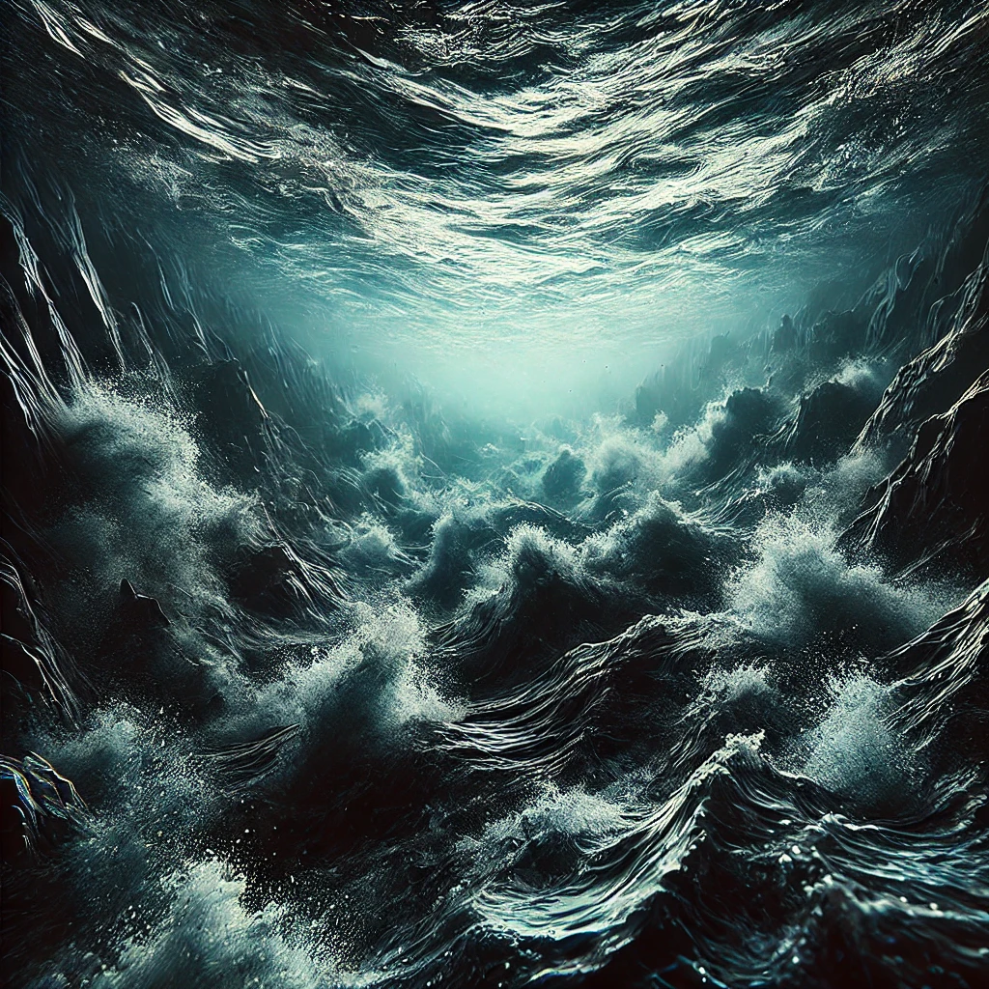

Fear: (Water darkens and ripples aggressively)

"Your fear stirs the water, causing it to darken and ripple with intensity."

Question 6:

"How do you cope with the uncertainties of climate change?"

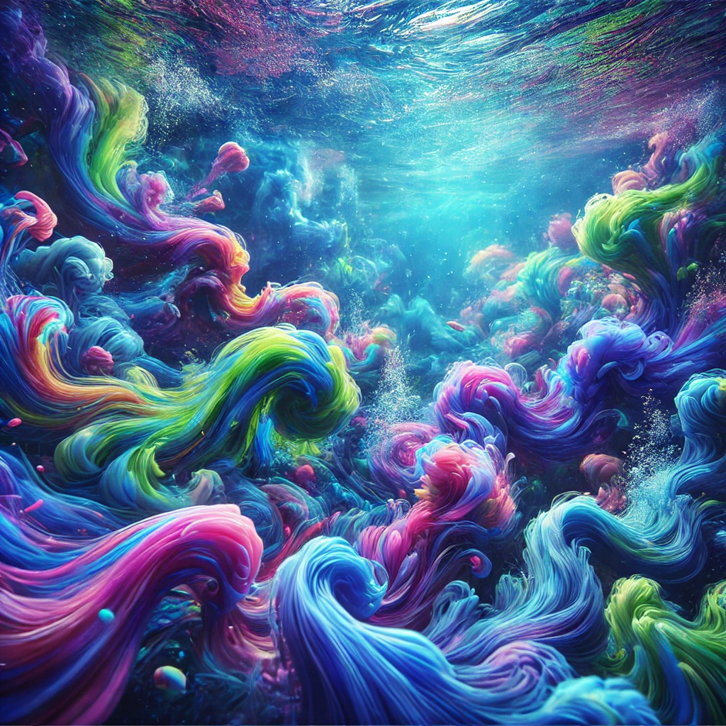

Proactive Coping: (Water becomes vibrant, with colorful currents)

"Your proactive approach creates vibrant, colorful currents in the water."

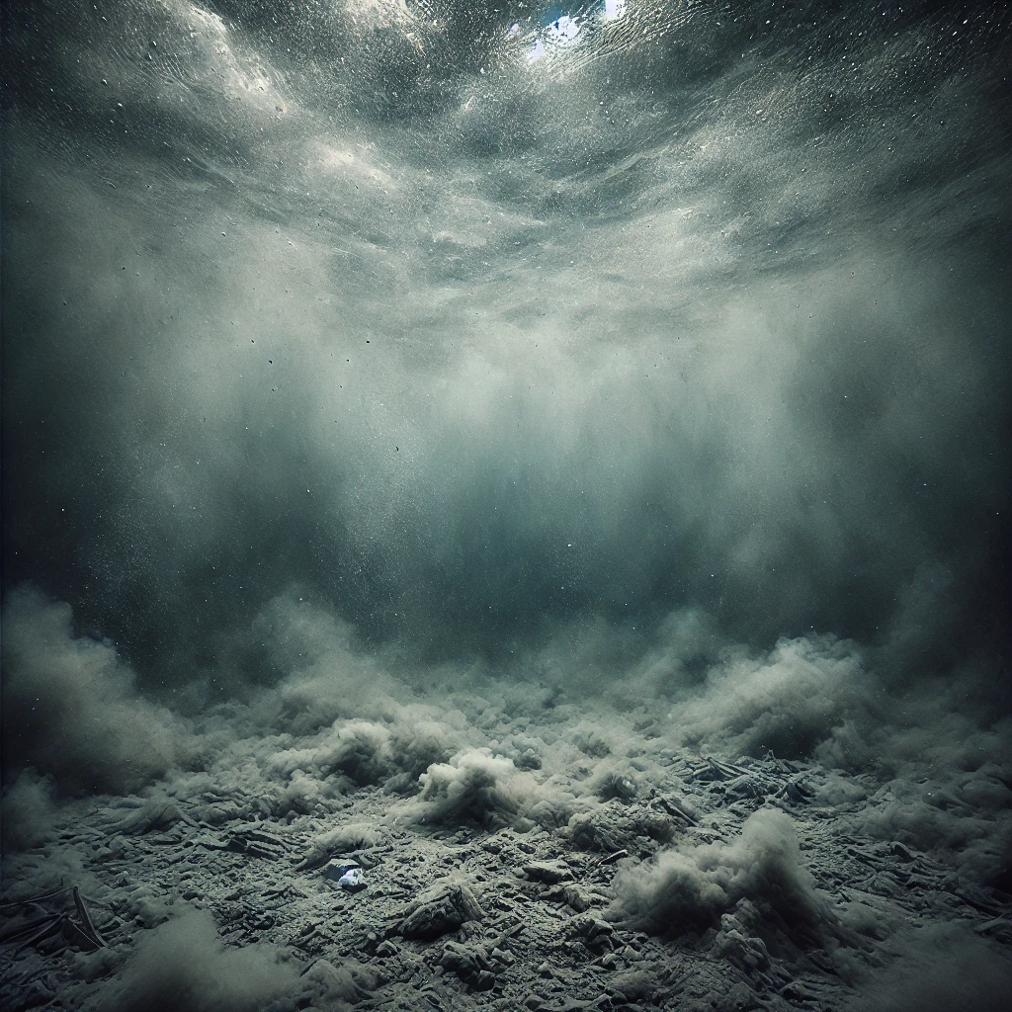

Avoidant Coping: (Water turns cloudy and stagnant)

"Your avoidance causes the water to become cloudy and stagnant, reflecting uncertainty."

Question 7:

"Do you believe that collective action can overcome climate challenges?"

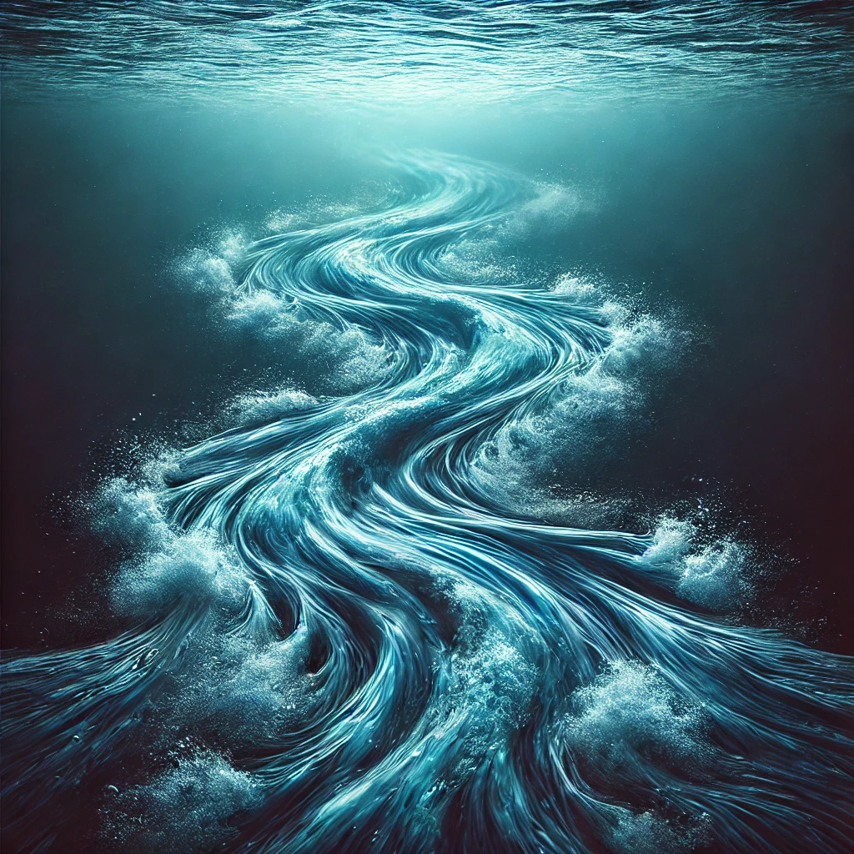

Affirmative Response: (Water unites into a cohesive, flowing stream)

"Your belief in collective action brings unity to the water, forming a cohesive, flowing stream."

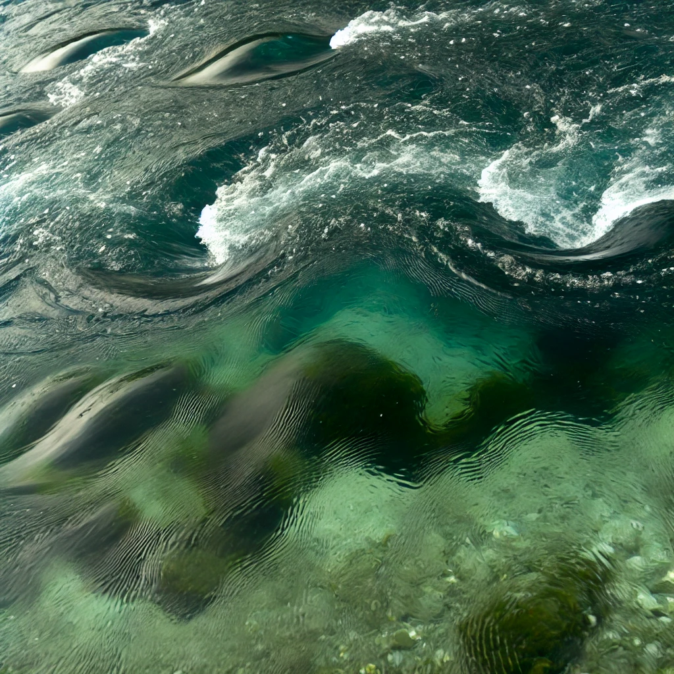

Skeptical Response: (Water separates into fragmented, swirling pools)

"Your skepticism causes the water to fragment and swirl, reflecting division and uncertainty."

Question 8:

"How do you feel about the progress being made in combating climate change?"

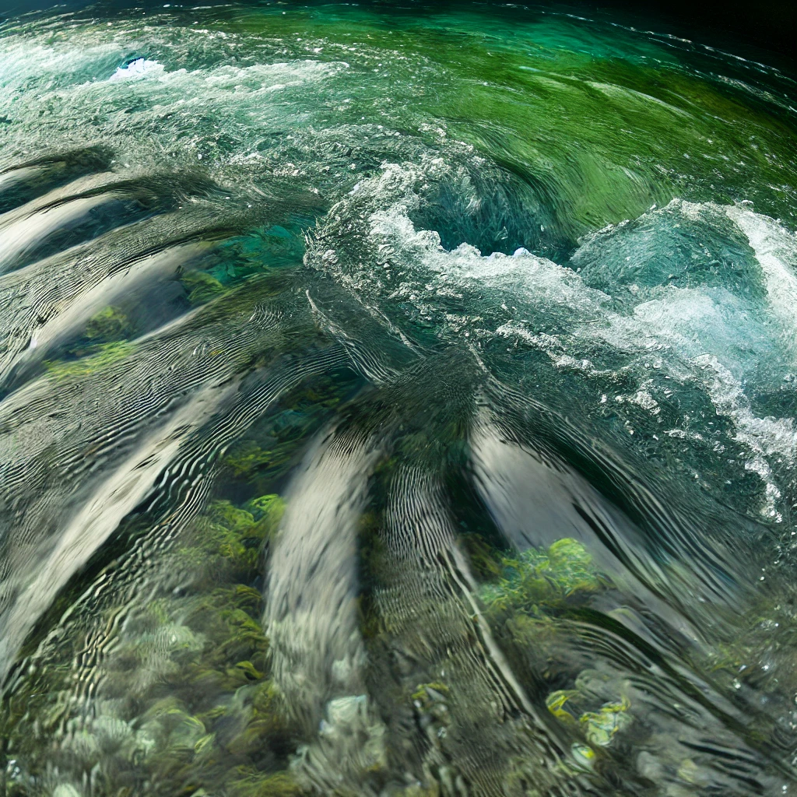

Positive Response: (Water clears and sparkles with light)

"Your positivity brightens the water, making it clear and sparkling."

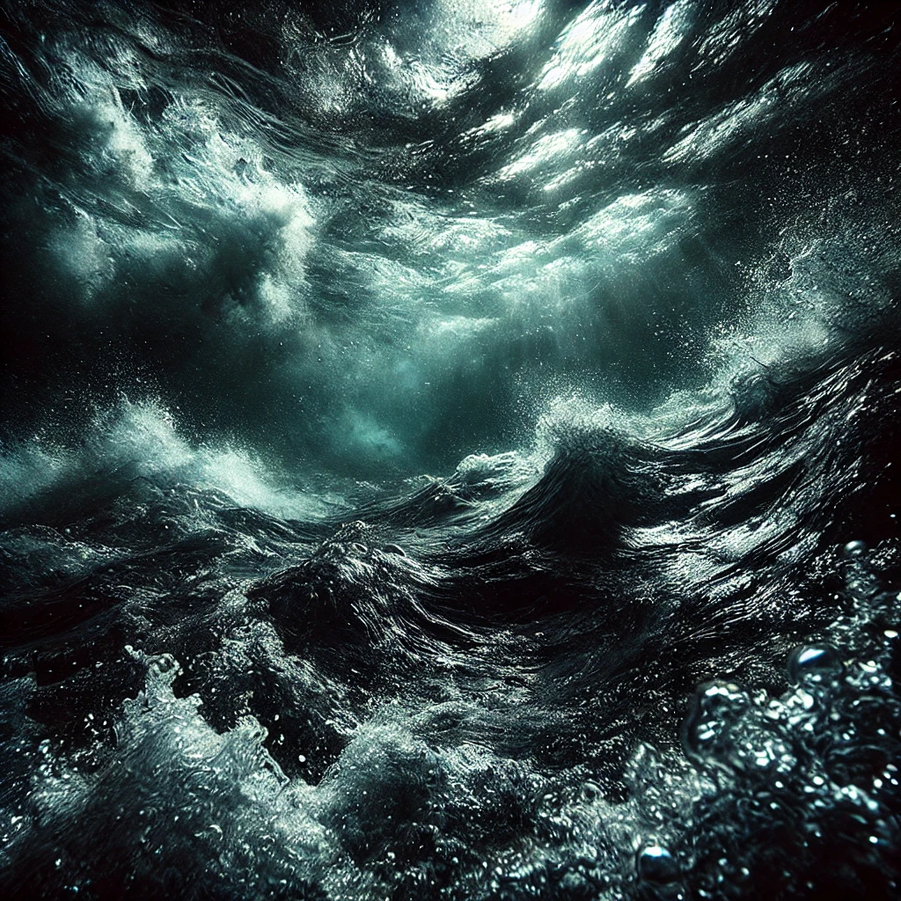

Negative Response: (Water becomes shadowed and turbulent)

"Your concerns cast shadows on the water, making it turbulent and dark."

Question 9:

"Do you find peace in nature despite concerns about climate change?"

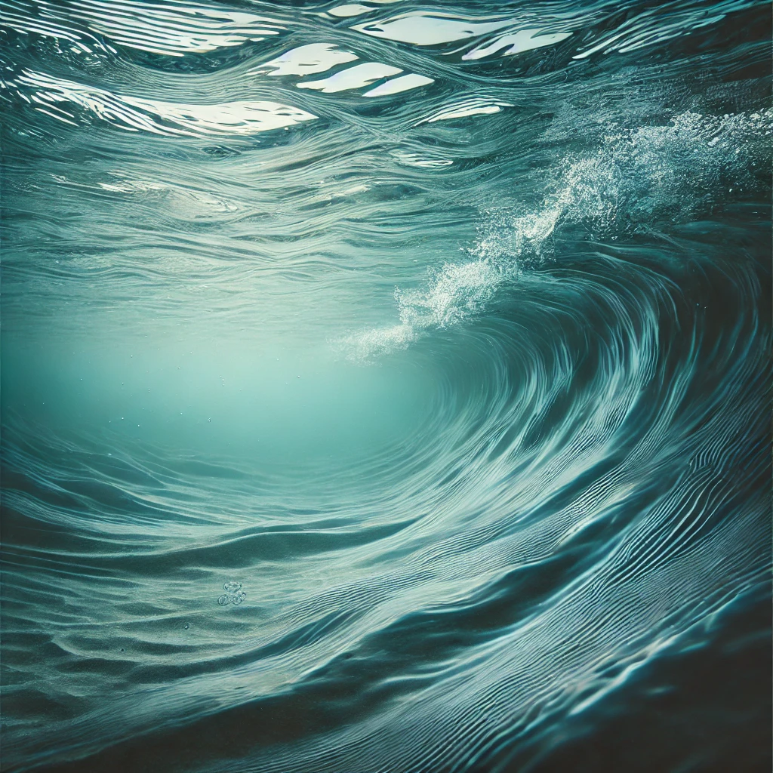

Peaceful Response: (Water becomes serene with gentle, lapping waves)

"Your connection to nature brings serenity to the water, with gentle, calming waves."

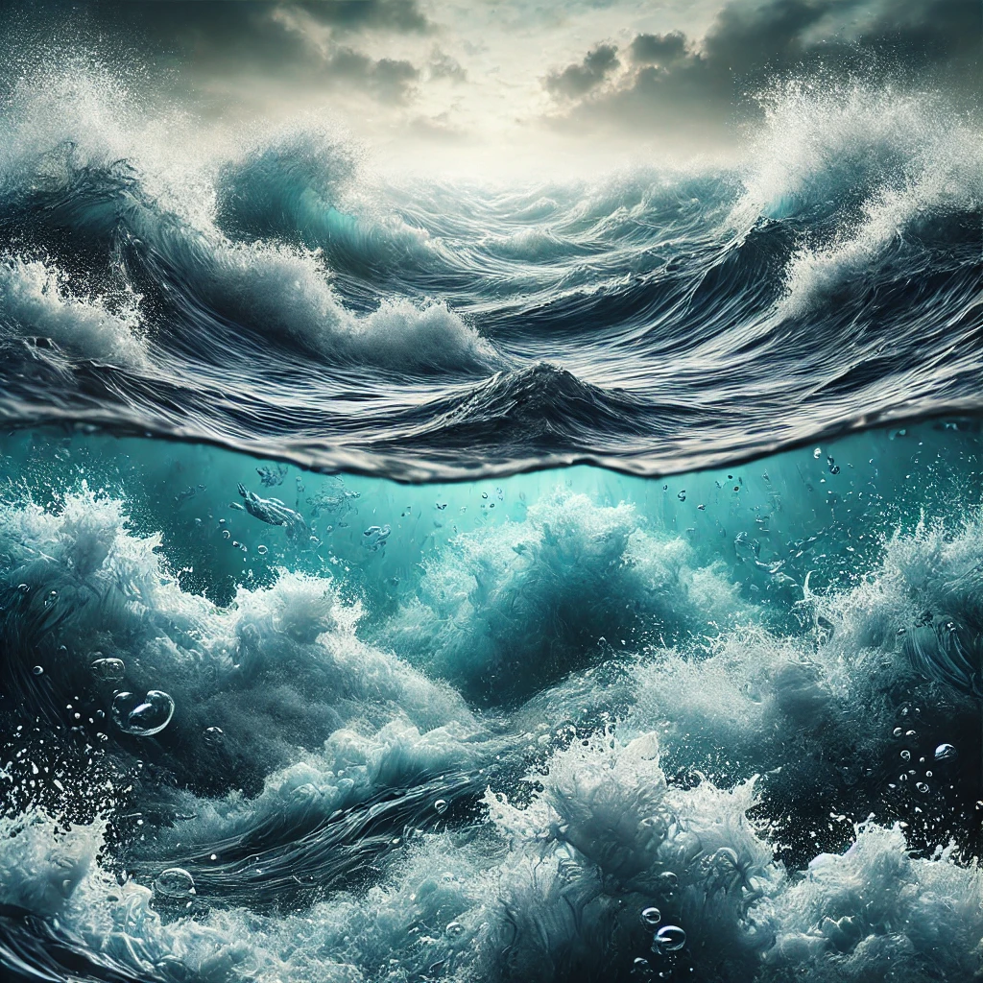

Distressed Response: (Water churns with restless energy)

"Your distress disrupts the water, causing it to churn with restless energy."

Question 10:

"How do you envision the future for the next generation regarding the environment?"

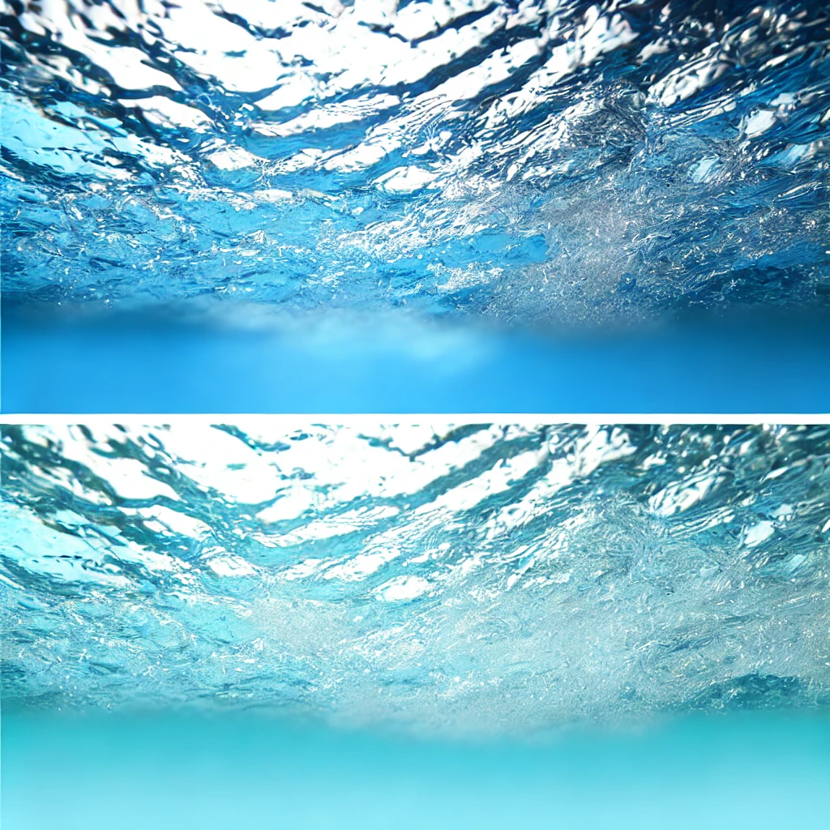

Optimistic Vision: (Water flows smoothly with a bright, clear hue)

"Your optimism for the future creates a smooth, bright flow in the water."

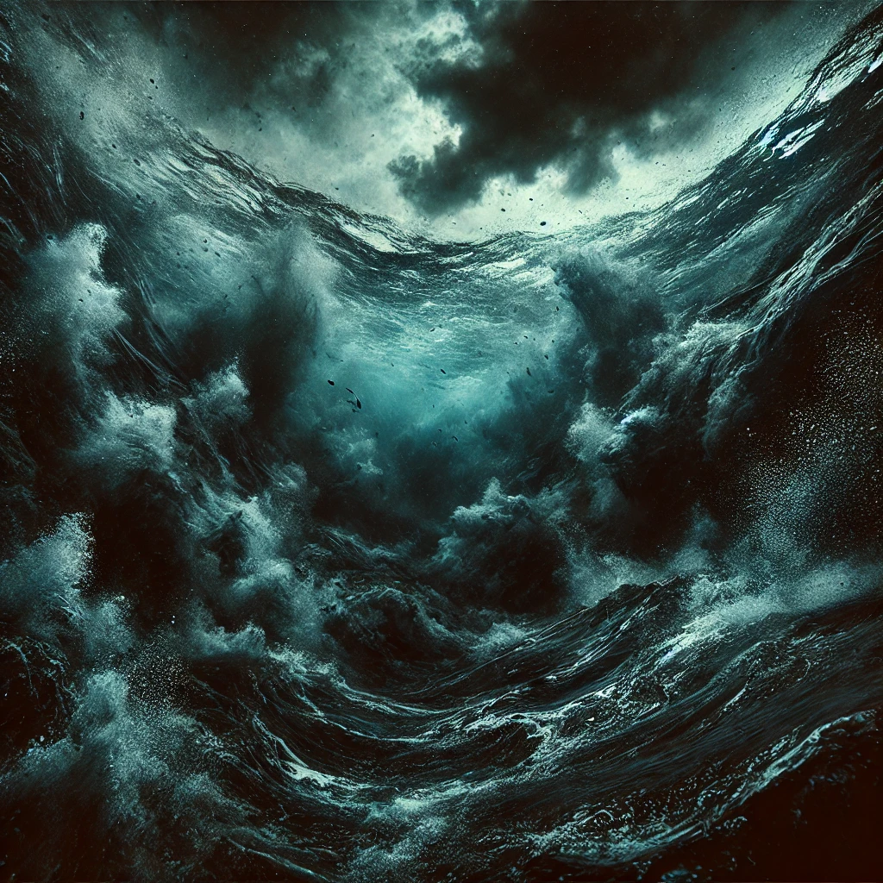

Pessimistic Vision: (Water turns dark and stormy)

"Your concerns for the future darken the water, making it stormy and intense."

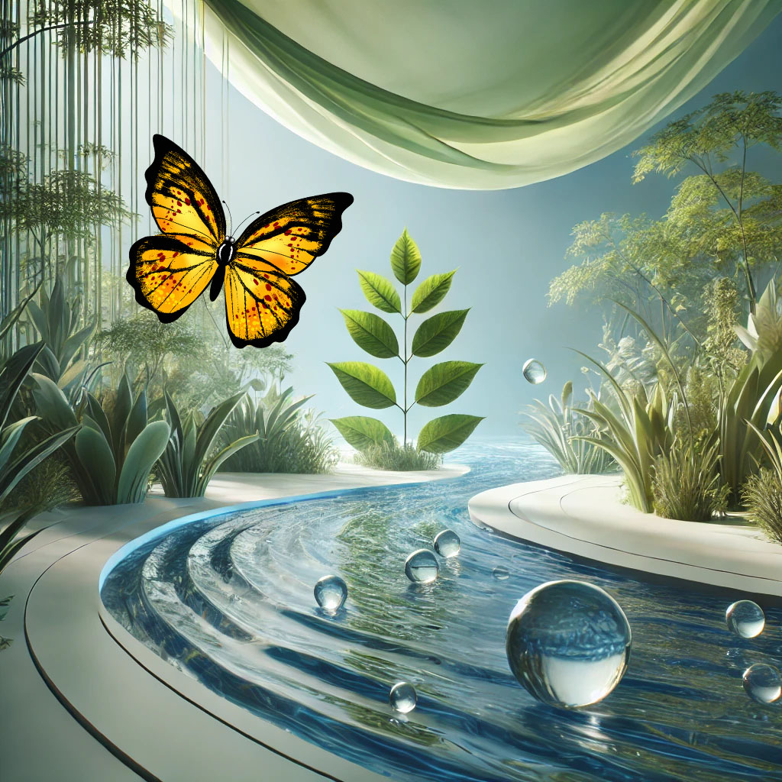Closing:

"Thank you for sharing your thoughts. As you can see, your emotions and perspectives have shaped this environment. Take a moment to reflect on how your inner landscape affects the world around you, and how you can navigate these emotions moving forward."